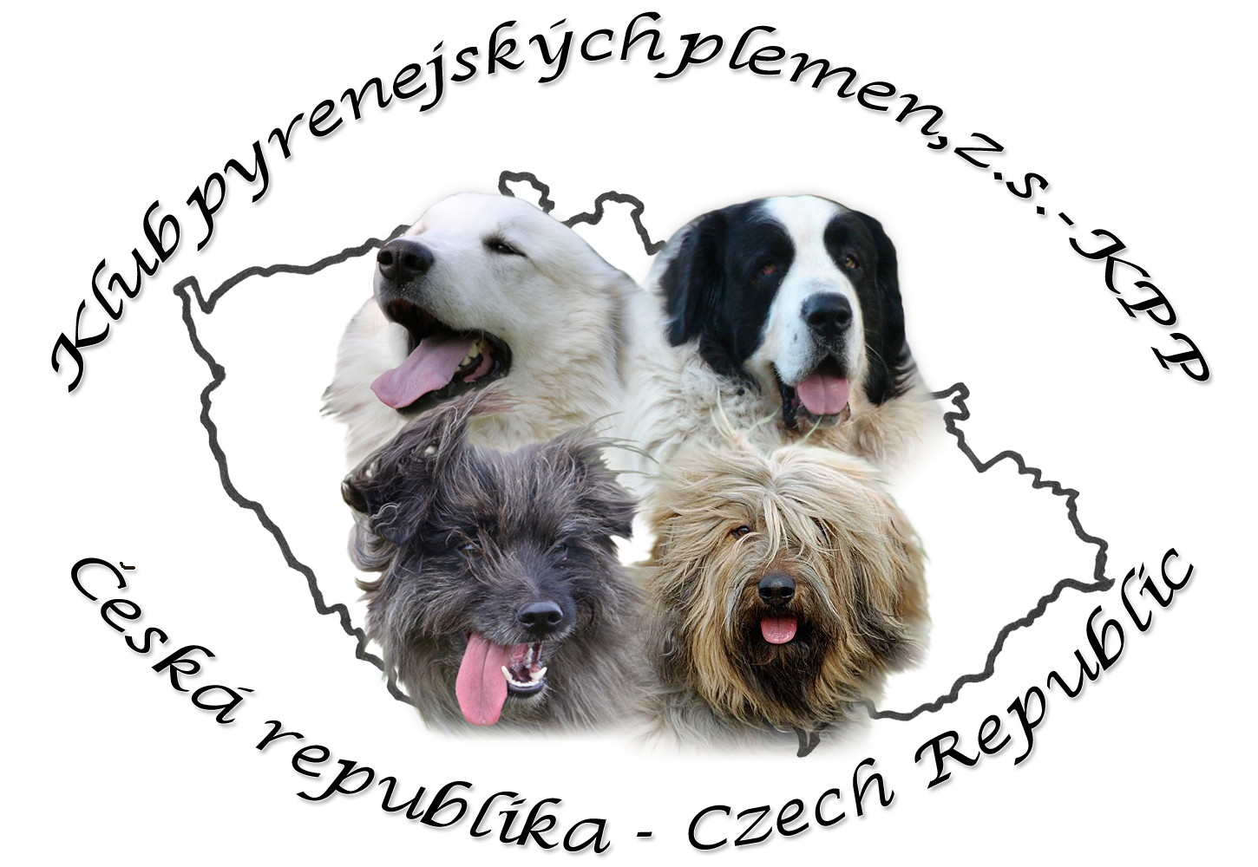
APPLICATION FORM
to the CLUB of the Pyrenean breeds

 | First name: |  |  |  | Surname:
Street: |  |  |  |  |  |  | Street number:
City: |  |  |  |  |  |  | ZIP:
Phone: |  | E-mail: |  |  |  | Web:
Kennel name: |  |  |  | Registration number of kennel:
Breed(s):
Name of the dog (also with kennel name): |  |  | Date of the birth: |  |  |  |  | Stud book number:
1.
2.
3.
4.

- Signing this application form to the Club of the Pyrenean breeds - KPP I completely filled in, I agree to comply with valid statutes, orders and directives of KPP, The Czech kennel club - ČMKU and FCI.

- I agree with the use of my personal data (name, address, phone number) in the club database of dogs (juniors, stud males or females), club bulletin and their use for internal needs of the club.

- I agree to publish all relevant information about my dog needed to confirmation for stud (name, date of birth, registration number, father, mother, HD result, owner).

- Enclose photocopy of both sides of the pedigree, will be used in the stud book of KPP

Pay the membership fee 25€ by bank transfer to the following account number:

IBAN: CZ87 6100 0000 0010 2558 4836
SWIFT/BIC: EQBKCZPP
Bank address: Equa bank a.s, Karolinská 661/4, 186 00 Praha 8, Czech republic
Account name: Klub pyrenejských plemen, z.s

Send scanned application form and the copy of payment to: predseda.kpp@gmail.com

In……………………………..Date………………………..Signature………………………

